**STATISTICS**

**ASSIGNMENT-8**

**EXERCISE 1.**

Suppose scores on exams in statistics are normally distributed with an unknown population mean and a population standard deviation of 3 points. A random sample of 36 scores is taken and gives a sample mean (sample mean score) of 68. Find a confidence interval estimate for the population mean exam score (the mean score on all exams).

Find a 90% confidence interval for the true (population) mean of statistics exam scores. 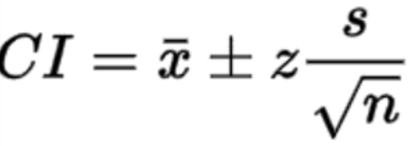

$\underline{x} = 68 -- Z = 1,65 acording to Z Table -- s=3 -- n = 36$

$Upper limit = 68+1,65(3/6)$ = 68.825

$Lower limit = 68-1,65(3/6)$ = 67.175

**EXERCISE 2.**

What is the normal body temperature for healthy humans? A random sample of 130 healthy human body temperatures provided by Allen Shoemaker7 yielded 98.25 degrees and standard deviation 0.73 degrees.

Give a 99% confidence interval for the average body temperature of healthy people.

n = 130 - std = 0.73 - conf int = 0.99+((1-0,99)/2) = 0.995 ===> 2,58 according to z table

- sample mean= 98.25

$Upper limit = 98.25+2.58(0.73/\sqrt{130})$ = 98.415

$Lower limit = 98.25-2.58(0.73/\sqrt{130})$ = 98.085

**EXERCISE 3.**

The administrators for a hospital wished to estimate the average number of days required for inpatient treatment of patients between the ages of 25 and 34. A random sample of 500 hospital patients between these ages produced a mean and standard deviation equal to 5.4 and 3.1 days, respectively.

Construct a 95% confidence interval for the mean length of stay for the population of patients from which the sample was drawn.

n = 500 patient -- sample mean = 5,4 days -- std =3.1 days

conf int = 0.95+((1-0,95)/2) = 0.975 ===> 1.96

$Upper limit = 5.4+1.96(3.1/\sqrt{500})$ = 5.671

$Lower limit = 5.4-1.96(3.1/\sqrt{500})$ = 5.128